Project Executable Files

Date | 30 June 2026
Team ID | xxxxxx
Project Name | OptiCrop Smart Agricultural Production Optimization Engine
Maximum Marks | 3 Marks

Project Executable Files
This section requires submission of all executable and deployable files for your project. Ensure all files are properly organized, named, and uploaded to the specified submission platform. The evaluator must be able to run or deploy your solution using the provided files and instructions.
Step 1: Submission Checklist

S.No | Item to Submit | Submitted (Yes /  No / NA)
1 | Complete source code (all files and folders) | YES
2 | README / Setup Guide (instructions to run the project) | YES
3 | requirements.txt / package.json / dependency file | YES
4 | Database schema / seed files (if applicable) | YES
5 | Environment configuration file (.env.example  or similar) | NO
6 | Deployed application URL (if hosted) | YES
7 | APK / Executable binary (if applicable for mobile/desktop apps) | YES
8 | Dockerfile / Containerization config (if applicable) | YES
9 | Test files and test results | YES
10 | Demo video or walkthrough (if required) | YES
Step 2: File / Folder Structure
Provide an overview of your project's file and folder structure below:
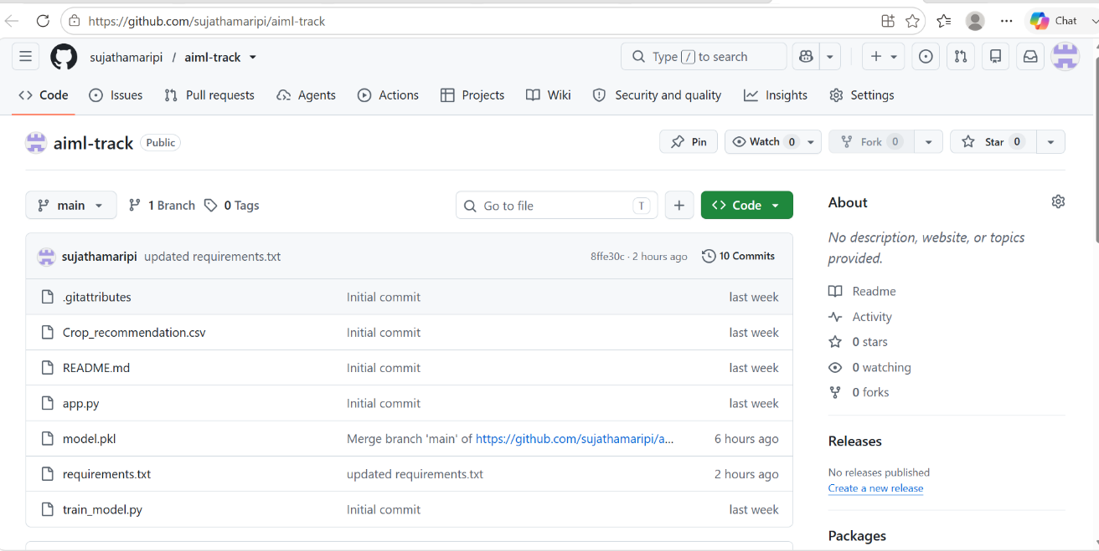
Step 3: Deployment / Access Details

Field | Details
Hosted / Deployed URL | Not hosted
Login  Credentials  (Demo) | No login required
Platform/Hosting Provider | Local
Repository Link | https://github.com/sujathamaripi/aiml-track
Demo Video Link | https://drive.google.com/file/d/1kKRDUPB6Jr0dnJXAxXzY2A_K_ki8b63/view?usp=drivesdk
Step 4: Run Instructions
Provide clear, step-by-step instructions for the evaluator to run your project locally: Follow these steps to run the OptiCrop application locally:
Step 1. Clone the repository: https://github.com/sujathamaripi/aiml-track
Navigate into the project folder: cd opticrop

Step 3. Install all dependencies: pip install -r requirements.txt
Step 4.Run the Flask application:
python app.py
Step 5.. Open your browser and go to: http://192.168.1.53:8501
Step 6. Run the streamlit application:
python app.py
Step 7. Navigate to 'Find Your Crop' → enter soil and climate values → click Predict.

Step 5: Known Issues / Limitations

S.No | Known Issue / Limitation | Workaround / Status
1 | No user authentication | user login
2 | Application runs only on local server | Can be deployed
3 | Model trained on a fixed dataset | Future scope includes training on a large dataset

